
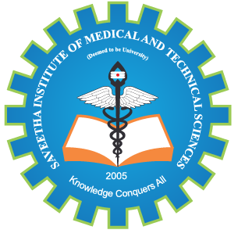
SIMATS ENGINEERING

Saveetha Institute of Medical and Technical Sciences
Chennai- 602105

Student Name: K.Aswini Reg. No.:192312397
Course Code: CSA1712 Slot: C
Course Name: Artificial Intelligence
Course Faculty: Dr.Veeramani R
Project Title:
AI-BASED CORAL HEALTH ASSESSMENT USING IMAGE CLASSIFICATION
Module Photographs: (3 photographs –Module Photo, Individual student contribution module work in the project and presentation image)
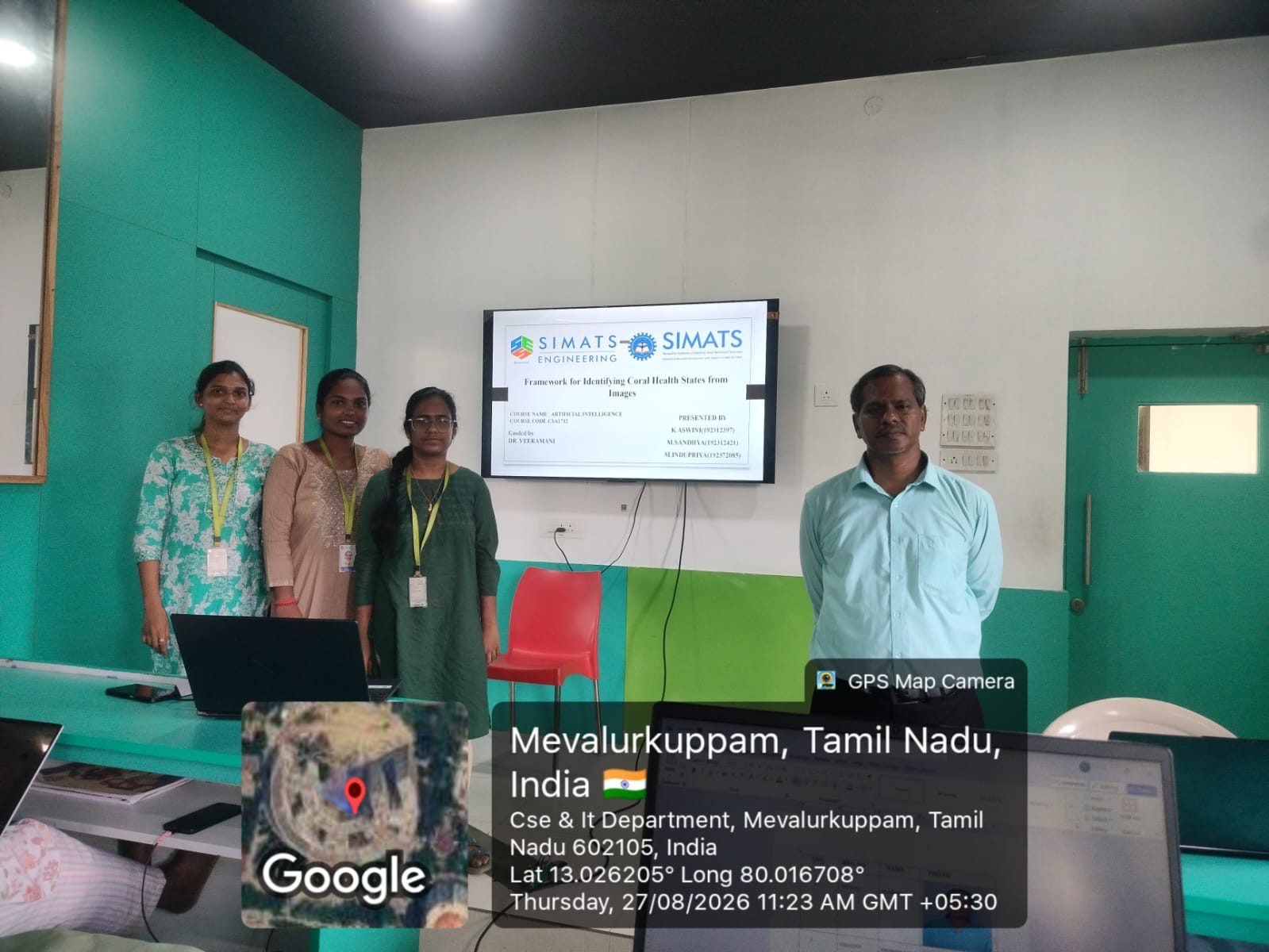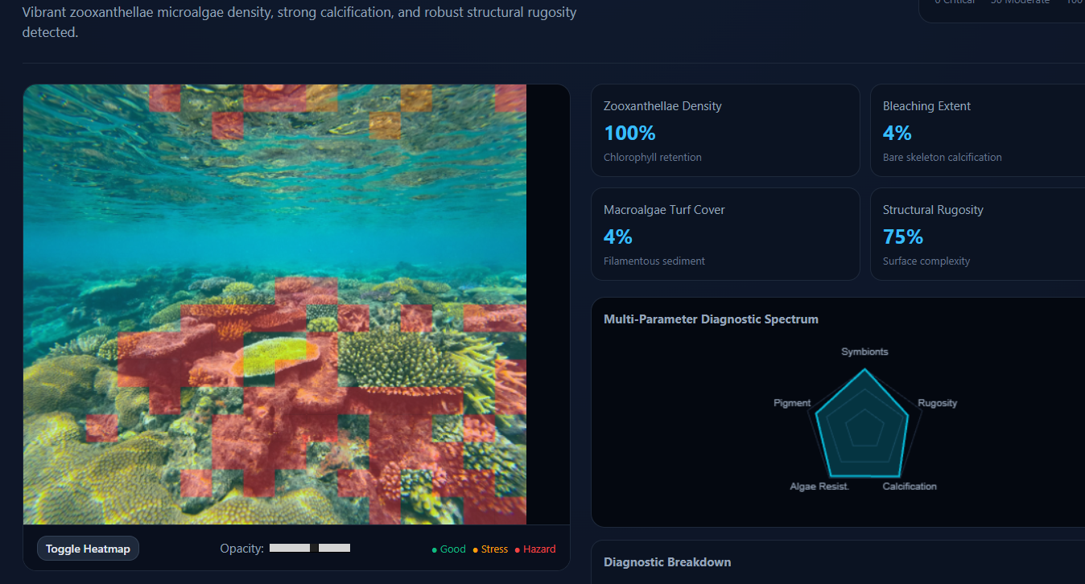
Project Description: Data Acquisition & Preprocessing
The data acquisition stage involves collecting a diverse set of underwater coral images from reliable sources such as publicly available datasets (e.g., Kaggle), marine research organizations, and real-time capture systems like underwater cameras or remotely operated vehicles (ROVs), ensuring representation of various coral health conditions including healthy, bleached, diseased, and dead, along with variations in lighting, water clarity, and viewing angles for better model generalization; these images are then labeled and organized systematically, after which preprocessing techniques are applied to enhance image quality by addressing common underwater issues such as noise, low contrast, and color distortion through methods like image resizing, noise filtering, white balance correction, histogram equalization, and normalization, along with data augmentation techniques such as rotation, flipping, scaling, and cropping to increase dataset diversity, ultimately producing clean, consistent, and high-quality input data for accurate feature extraction and classification.

Student Signature Guide Signature

